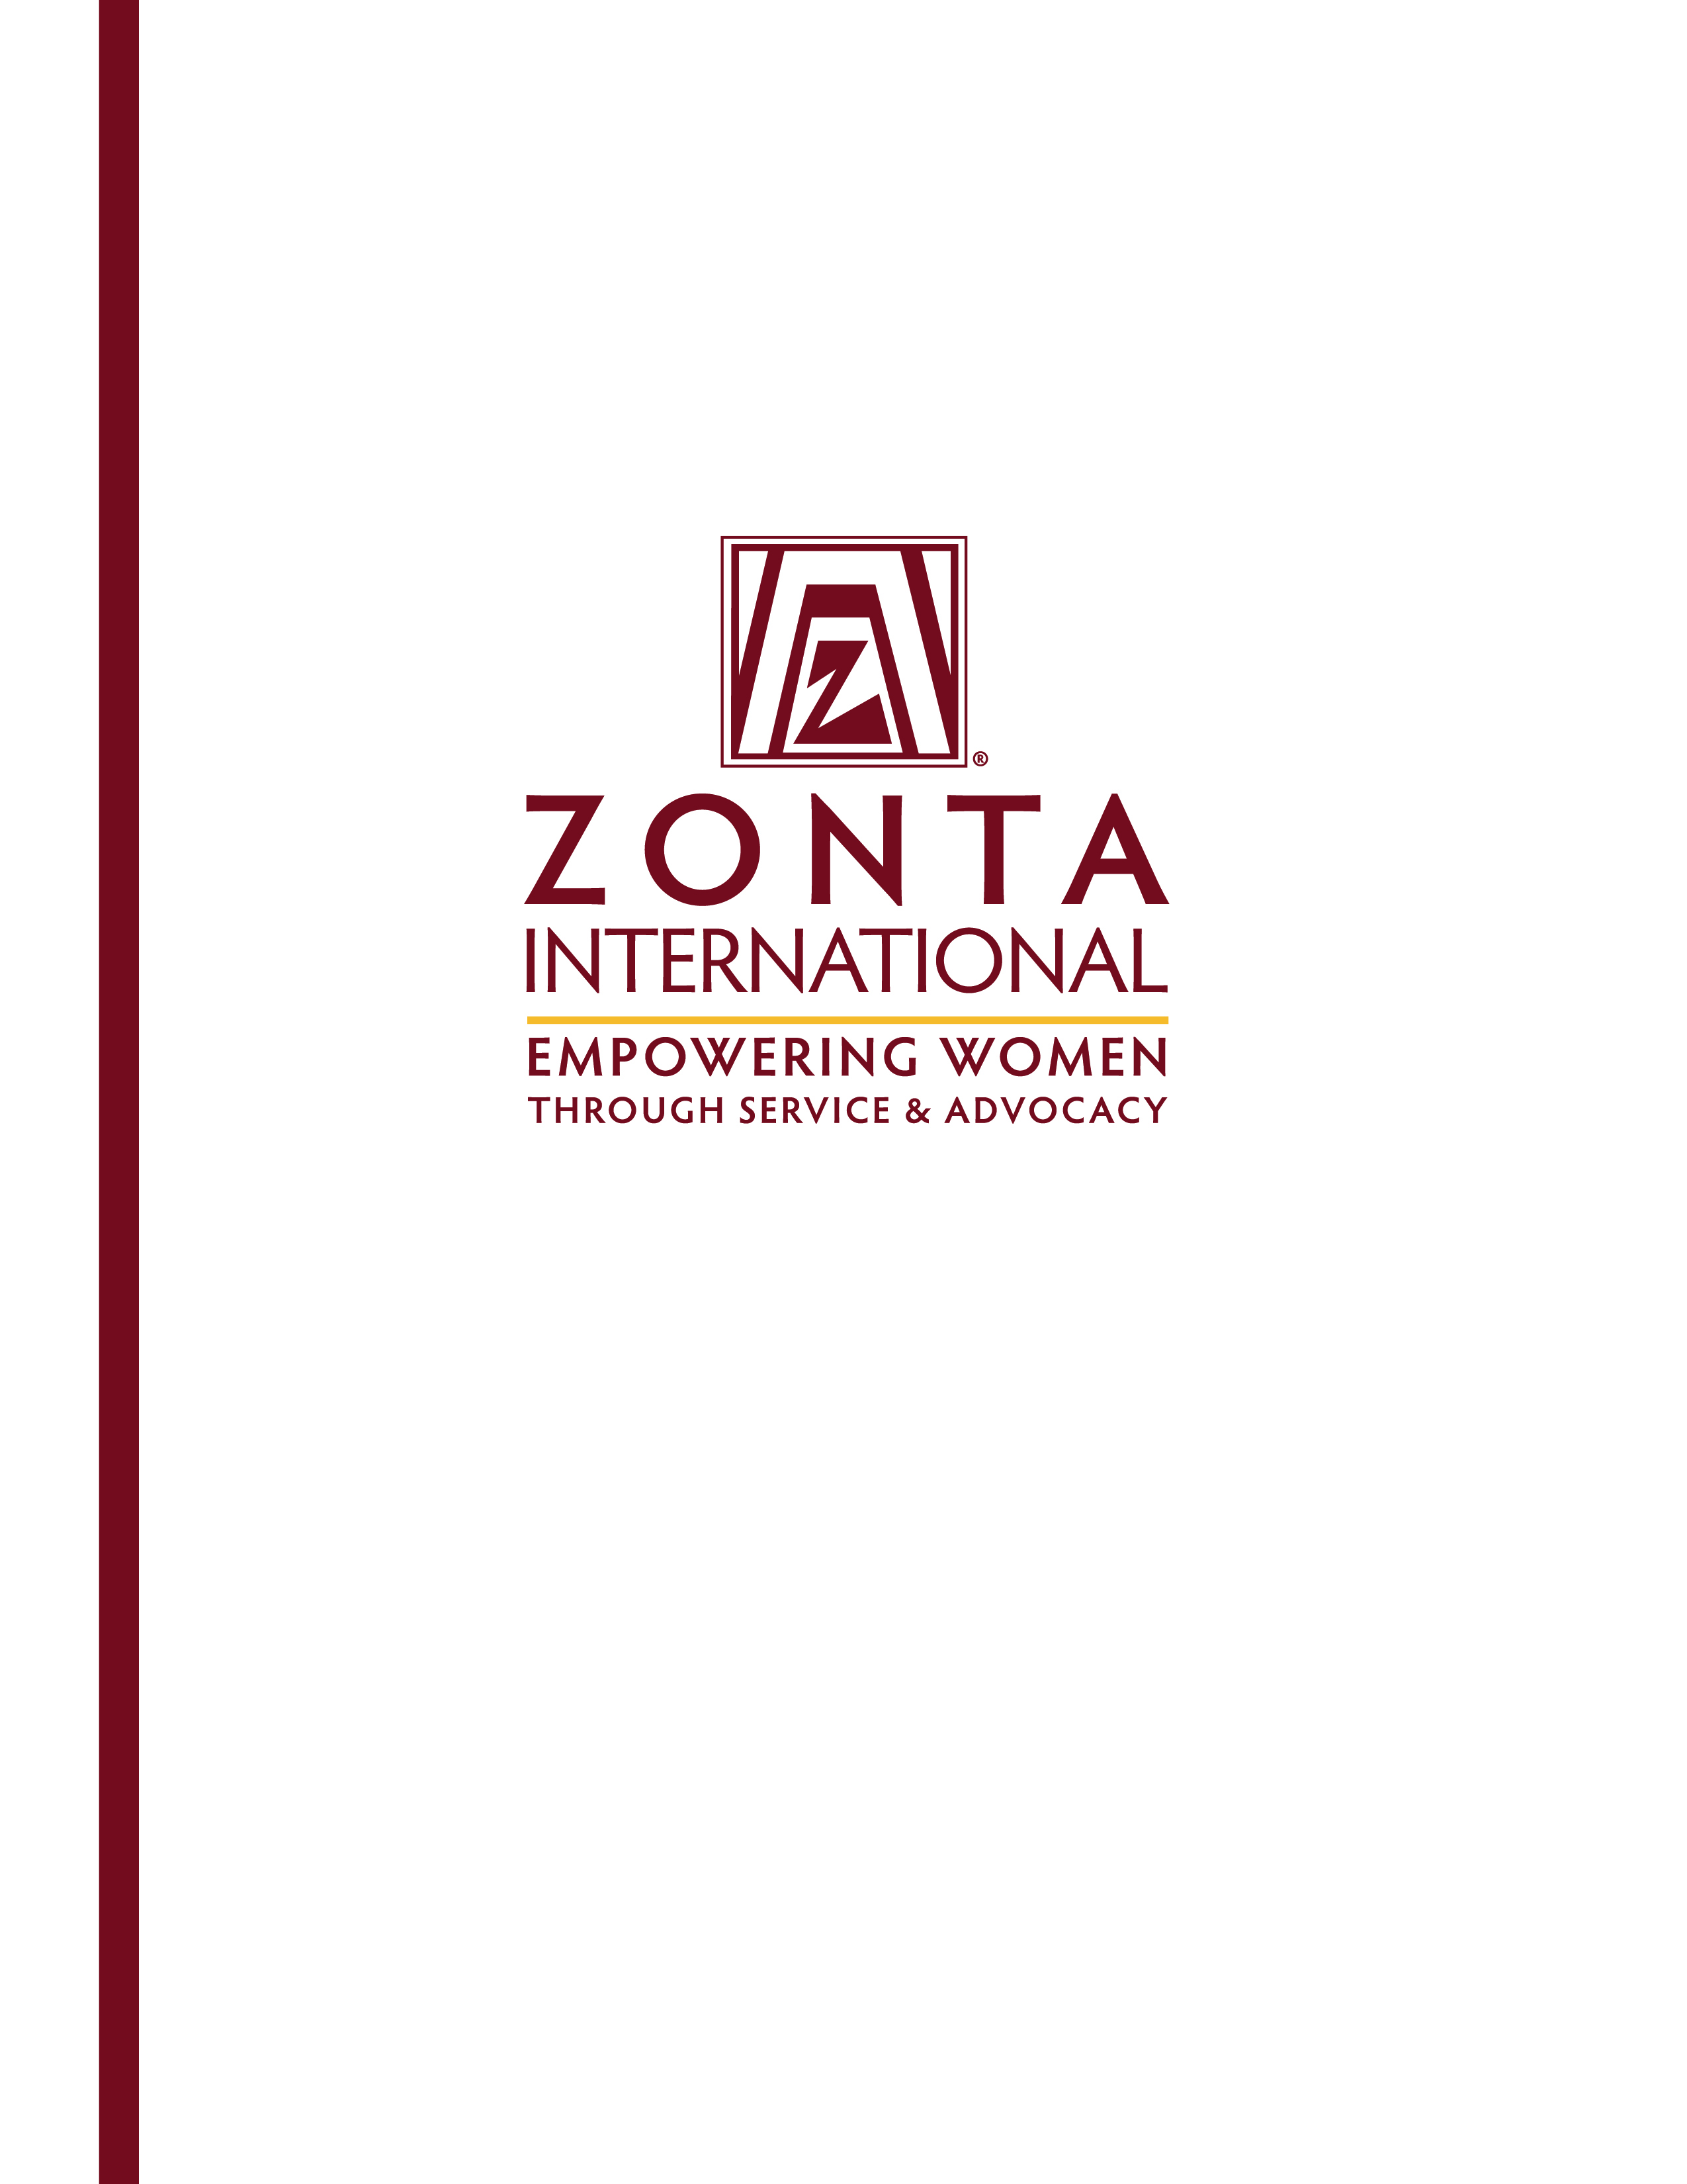
Heading
Subheading

Young Women in Public Affairs Award
2018 Application

Young Women in Public Affairs Award
A Zonta International Program with Local, District and International Awards

General Information
The goal of the Zonta International Young Women in Public Affairs (YWPA) Award Program is to encourage young women to participate in public affairs by recognizing a commitment to the volunteer sector, evidence of volunteer leadership achievements and a dedication to empowering women worldwide through service and advocacy.

In order for more women to be represented in key decision-making positions worldwide, we must encourage young women to pursue careers or seek leadership positions in public policy making, government and volunteer organizations and further their education with these aims in view.

‘Public affairs’ refers to all aspects of community life where decisions have to be made about issues which relate to and affect those communities in which people work and live.

The Awards
The Zonta Club of Milwaukee awards a $1,000 local scholarship to an applicant living in the greater Milwaukee area and forwards the winner’s application to Zonta District 6 to be considered for the $1,500 district award. The district winner’s application is then sent to Zonta International; 10 international recipients are selected from the worldwide district/region recipients to receive additional awards of $4,000 each. District/region and international awards are funded by the Zonta International Foundation.

Who Is Eligible?
Women, ages 16-19 on April 1 each year, living in a Zonta district/region, or who are citizens of a Zonta country, who demonstrate evidence of the following, are eligible to apply. Note that applicants from geographic areas within a Zonta district/region where no clubs are located will be eligible for the district/region and international awards. Z and Golden Z club members are also eligible to apply. Classified members and employees of Zonta International and Zonta International Foundation, and their family members, are not eligible to apply for the Awards.

- Active commitment to volunteerism.
- Experience in local government, student government, or workplace leadership (paid or unpaid).
- Volunteer leadership achievements.
- Knowledge of Zonta International and its programs.
- Support for Zonta International’s mission of empowering women worldwide through service and advocacy.

Application Requirements
- Completion of the official application (may be downloaded from the Zonta Club of Milwaukee website, www.zontamilwaukee.org, or the Zonta International website, www.zonta.org).
- Verification of current enrollment by school/institute official (if applicable), or
- Letter from employer stating employment (if applicable).
- Two confidential recommendations from adults, not related to the applicant, such as teachers, school officials/employee supervisors or community leaders.

Supporting documentation not requested will not be considered. All applications and supporting information become the property of Zonta International. Zonta International has final authority over any aspect of the awards.

Application process
The application process must start with a Zonta club. All application materials must be received at a Zonta club by the printed deadline. Please contact your local Zonta club for deadline information. You may locate the Zonta club nearest you using the Club Locator at www.zonta.org, or e-mail your name and contact information to the International Young Women in Public Affairs Award Committee Chairman at ywpachairman@zonta.org.

Zonta clubs each select one application to send to the Zonta governor/region representative. A district/region evaluating committee reviews the applications and selects one applicant per district/region to submit to Zonta International Headquarters. The Zonta International YWPA Committee recommends 10 international recipients from the district/region applications to the Zonta International Board. After approval by the Zonta International Board, the Zonta International Foundation provides awards and certificates to the district/region and international recipients.

Timetable
Application is posted on the Zonta International website (www.zonta.org) .......................................... by 1 August
Application is due to and received by Zonta Club of Milwaukee….….…...................................... by 15 March
Club recipients selected and applications received by governor/region representative........…................ by 1 April
District/region recipients selected and applications received by Zonta International Headquarters......... by 1 May

Announcement of district/region and international recipients……………………...………….…….......…… 1 July

Application for
Young Women in Public Affairs Award

Send applications and direct questions to:
Zonta Club of: | Milwaukee
c/o: | Krista Betts
Address: | 5387 S 21st Street
City/State: | Milwaukee, WI 53221
Province/Country: | USA
Telephone: | 630-965-5929
Email Address: | zcscholarship@zontamilwaukee.org
Application Deadline: March 15, 2018

Name:
 | Last (Family) | First (Given) | Middle

Present Mailing Address:

City: |  | State: |  | Postal Code: |  | Country:

Telephone: |  | E-mail Address:

Birthdate: |  | Birthplace: |  | Country of Citizenship:
(date/month/year) (city/country)

Name and Address of School/Institute currently attending (if applicable):

Name and Address of Employer (if applicable):

Current year of study (if applicable):

PERSONAL GOALS
Please describe in short your anticipated course of study and current career interests, including whether and how you plan to be active in volunteer or community organizations. (150 words) Please provide the word count at the end of your answer.

DECLARATION BY APPLICANT
I certify that all of the information contained in my application form is accurate to the best of my knowledge and that I did not receive assistance in completing the essay portions of this application. I confirm that I am not a family member of a classified member and/or employee of Zonta International. I understand that, at the option of the Zonta club sponsoring the competition, I may be interviewed as a candidate for the Young Women in Public Affairs Award. I consent to the electronic or hard copy publication by Zonta International of material in my application.

Date |  | Signature (Insert image of your signature or print, sign and scan this page.)

DATA PROTECTION
Zonta International and Zonta International Foundation take the security of data seriously. We will never sell, trade or rent your personal information provided in this application to third parties. By submitting this application you agree to the use of your data in accordance with the Privacy Policy and Publicity Authorization Form contained in the application documents (see page 9 of the application).

Please answer all questions below, noting the word limit for each. Preference will be given to those applicants who observe the word restrictions. In evaluating applications all questions are rated in equal value.
Question

1. Activities related to your school/workplace. Please include (a) your leadership experience, and (b) what you find most rewarding or valuable about your participation in these activities (no more than 200 words). Please provide the word count at the end of your answer.

2. Activities not related to your school/workplace. Describe the activities in which you participate as a volunteer that benefit other causes and any leadership roles you have had in those activities.
Please include with these activities a description of any experience in local government, international, or other projects (no more than 200 words). Please provide the word count at the end of your answer.

3. International Awareness
Describe the activities you participate in which increase your experience, knowledge and understanding of other countries and their different customs (no more than 150 words). Please provide the word count at the end of your answer.

4. Status of Women in your Country and Worldwide
Describe your experience in empowering women worldwide through service and advocacy. Are there any issues which hinder women’s empowerment in your country and worldwide? Describe your ideas for resolving them (no more than 300 words). Please provide the word count at the end of your answer.

Checklist to be completed by applicant:
Verification of current enrollment by school/institute official (if applicable), or
Letter from employer stating employment (if applicable)
Completed application materials, typed in English
Two confidential recommendation letters with signatures
Applicant’s signature (required)

Recommendation for
Young Women in Public Affairs Award

Please return this form by: | March 15, 2018
To Zonta Club of: | Milwaukee
c/o | Krista Betts
Address: | 5387 S 21st Street
Postal code/City/State/Country: | Milwaukee, WI 53221 USA
Email: | zcscholarship@zontamilwaukee.org

Applicant:
 | Last (Family) Name | First | Middle

Recommendation from:
 | Name (please print) | Position/Title

Recommendation for Applicant for Zonta International Young Women in Public Affairs Award
The applicant above has applied for a Zonta International Young Women in Public Affairs Award. Please discuss the applicant’s accomplishments, motivation, potential for public service and awareness of women’s and community issues. Note that you may instead write your recommendation letter on letterhead of your choice, then sign and submit with this form. This recommendation form must be signed and submitted directly to the address above.

Date |  | Signature (Insert image of your signature or print, sign and scan this page.)

Recommendation for
Young Women in Public Affairs Award

Please return this form by: | March 15, 2018
To Zonta Club of: | Milwaukee
c/o | Krista Betts
Address: | 5387 S 21st Street
Postal code/City/State/Country: | Milwaukee, WI 53221 USA
Email: | zcscholarship@zontamilwaukee.org

Applicant:
 | Last (Family) Name | First | Middle

Recommendation from:
 | Name (please print) | Position/Title

Recommendation for Applicant for Zonta International Young Women in Public Affairs Award
The applicant above has applied for a Zonta International Young Women in Public Affairs Award. Please discuss the applicant’s accomplishments, motivation, potential for public service and awareness of women’s and community issues. Note that you may instead write your recommendation letter on letterhead of your choice, then sign and submit with this form. This recommendation form must be signed and submitted directly to the address above.

Date |  | Signature (Insert image of your signature or print, sign and scan this page.)

Verification of Current Enrollment
Young Women in Public Affairs Award

Please return this form by: | March 15,2018
To Zonta Club of: | Milwaukee
c/o | Krista Betts
Address: | 5387 S 21st Street
Postal code/City/State/Country: | Milwaukee, WI 53221 USA
Email: | zcscholarship@zontamilwaukee.org

School/Institute:

I certify that |  | is currently enrolled in
 | (name)

 | at
(grade level) |  | (name of school/institute currently attending)

(address of school/institute currently attending)

Date |  | Signature of School/Institute Official

(Official School/Institute Stamp)

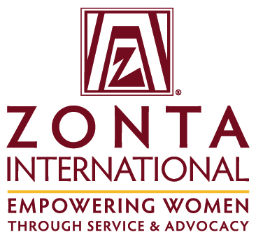

Zonta International Young Women in Public Affairs (YWPA) Award

Privacy Policy and Publicity Authorization

Zonta International and the Zonta International Foundation are committed to honoring the privacy and wishes of all of our Young Women in Public Affairs (YWPA) Award recipients at all times. In order to do this, please read the following information carefully and indicate your agreement as appropriate.

- Most data collected by Zonta International and the Zonta International Foundation is used only to help Zonta better serve its award recipients. It is our general policy to collect and store only personal information that our recipients knowingly provide. Zonta does not sell, trade, or rent your personally identifying information to third parties. We take reasonable measures not to disclose personally identifying information about you.

I have read the above paragraph and agree to the Terms and Conditions therein.

- From time to time, Zonta International/Zonta International Foundation conducts various marketing activities to promote the YWPA Award Program. In addition, to ensure Zonta’s ability to fund the Awards, the Zonta International Foundation may from time to time provide information to donors to the YWPA Award Fund about recipients of their donations. Zonta retains the right to use your name, photograph and biographical information to promote the YWPA Awards in various promotional materials, including the Zonta International website.

I have read the above paragraph and agree to the Terms and Conditions therein.

Signature (Insert image of your signature or print, sign and scan this page.) Date

Please print your name

