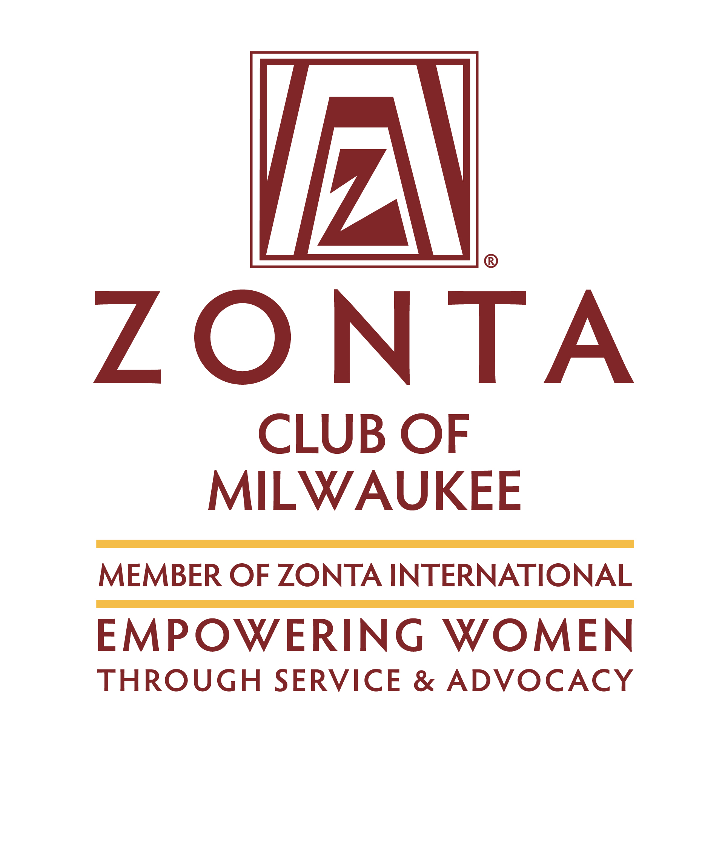
Women in STEM Scholarship
(Science, Technology, Engineering, Math)

2020 Application

Women in STEM Scholarship
A Scholarship from the Zonta Club of Milwaukee

About Zonta
Founded in 1919, Zonta International is a leading global organization of professionals empowering women worldwide through service and advocacy. With more than 30,000 members belonging to more than 1,200 Zonta Clubs in 67 countries and geographic areas, Zontians all over the world volunteer their time, talents and support to local and international service projects, as well as scholarship programs aimed at fulfilling Zonta's mission and objects. More information about Zonta International and the Zonta Club of Milwaukee can be found at www.zonta.org and www.zontamilwaukee.org

The Women in STEM Scholarship
As a means of encouraging more women to pursue undergraduate degrees in Science, Technology, Engineering or Math, the Zonta Club of Milwaukee is sponsoring a $1,000 Women in STEM Scholarship competition for local residents and out-of-state students, to help fund junior or senior level studies at an accredited university, college or institute.

Who Is Eligible?
Women of any age pursuing an undergraduate degree in Science, Technology, Engineering or Math, with either legal residency or out-of-state student status in the six-county Greater Milwaukee Metro area are eligible to apply. Applicants should demonstrate outstanding potential in the field.

Applicants must either: (1) have legal residency in the six-county Greater Milwaukee Metro area while attending any accredited university, college or institute in the world or (2) be a full-time, out-of-state student attending an accredited university, college or institute in Milwaukee, Waukesha, Washington, Ozaukee, Kenosha, or Racine County.

Applicants must have a strong overall academic record, and must have achieved junior- or senior-level status by June 15, 2020.

Previous Women in STEM Scholarship recipients may not apply to renew the scholarship for a second year. Classified members and employees of Zonta, and their family members, are not eligible to apply for the scholarship. Golden Z club members may apply.

What Are the Requirements?
Applicants must meet the following minimum requirements:
- Be a legal resident or full-time out-of-state student in the six-county Greater Milwaukee Metro area.
- Be enrolled in a STEM-related program at an accredited university/college/institute.
- Have or will have achieved junior- or senior-level status by June 15, 2020.
- Still be attending school at the time the scholarship funds are disbursed.
- Have earned an outstanding academic record, including in STEM subjects.
- Demonstrate initiative, ambition and commitment to pursuing a career in a STEM field.
- Display a commitment to volunteerism, service and/or advocacy.

How Do I Apply?
Complete an official application in English. Please note that only typed applications will be accepted and considered. Applications can be downloaded from the Zonta Club of Milwaukee website (www.zontamilwaukee.org) and must include:
- One recommendation from a faculty member in the major field of study.
- One recommendation from an employer, volunteer supervisor, or academic advisor. (Classified members and employees of Zonta are not eligible to write recommendation letters for applicants.)
- An essay in 500 words or less that clearly describes your academic and professional goals, the relevance of your program to your chosen STEM field, and how the Zonta Club of Milwaukee Women in STEM Scholarship will assist you in reaching your goals. (Essays exceeding 500 words will not be considered.)
- Verification of current enrollment form from the university/college/institute registrar (see page 10 of application). Acceptance letters are not verification of enrollment and will not be accepted.
- Official detailed transcripts of grades or equivalent records for all universities, colleges, or institutes attended, with an explanation of the grading system for each transcript submitted.
- All non-English documents must be translated into English.
- All application materials must be received at the Zonta Club of Milwaukee by the June 15, 2020, deadline.
- Articles, pamphlets, books, curriculum vitae or other publications are not requested and will not be considered.
- Applications that are incomplete or late due to postal delays, transmittal by third parties, or other circumstances will not be considered. Applications are accepted by email or regular mail; however, email submissions are preferred. Applications submitted by email must be signed and sent as a PDF.

What Is the Application Process?
The Zonta Club of Milwaukee Scholarship Evaluation Committee will consider applications, select the awardee and notify her by July 15, 2020.

How May I Use the Scholarship Funds?
- The scholarship may be used for any expenses that support the achievement of a degree in a STEM-related field.
- For domestic and foreign recipients studying in the United States, scholarship funds used for tuition, books, fees, supplies or required equipment for the program of study are not considered taxable income. Withholding taxes may be required on funds used for living expenses or other non-qualified expenses.
- Recipients are not permitted to defer the scholarship.
- Recipients may accept additional grants and scholarships from other sources.

Timetable

Applications received by Zonta Club of Milwaukee……………………………………………………………………….15 June

Club recipient is selected and notified…………………………………………………………........................................15 July

Application for Women in STEM Scholarship

(Science, Technology, Engineering, Math)
SEND APPLICATION AND DIRECT ANY QUESTIONS TO:

Application Deadline: | June 15, 2020
Zonta Club of: | Milwaukee
Attention: | Krista Betts
Address: | 5387 S 21st Street
City/State: | Milwaukee, WI 53221
Province/Country: | USA
Telephone: | 630-965-5929
Email address: | zcscholarship@zontamilwaukee.org

Name:
 |  | Last (Family) | First | Middle

Present mailing address:

City: |  | State: |  | Postal Code: |  | Country:

Email address: |  | Telephone:

Permanent Mailing Address:

City: |  | State: |  | Postal Code: |  | Country:

Home email address: |  | Telephone:

Birth date: |  | Birthplace: |  | Country of citizenship:
(date/month/year)
University/college/institute currently attending: |  |  | Current year of study:

Department: |  | Major/field of study:

Plans for study under the Women in STEM Scholarship:

Degree sought: |  | Expected graduation date (month/year):

Academic Background
Applicants are required to send transcripts of grades or equivalent records from all universities, colleges or institutes attended. An explanation of the grading system must be included for each transcript. Please include current degree sought and expected graduation date (month/year).

University/college/institute | (Year) to (Year) | Major field | Date of degree/anticipated
Scholarships, Fellowships, Honors Received During the Studies Listed Above
(Attach an additional sheet if necessary)

Date:
Date:
Date:
Date:
Date:
Date:
Date:
Volunteer and Other Activities
(Please describe your volunteer, non-scholastic activities, memberships and cultural interests):

Employment

From (month/year) | To (month/year) | Employer | Address | Type of work or position held

Recommendations
Please give one of the attached recommendation forms to a faculty member in the major field of study and the other to an employer, volunteer supervisor, or academic advisor.

Please list below those who will submit recommendations:

Name | Position | College/university/institute
1.
2.

Declaration by Applicant

I will take responsibility for school expenses (such as living, traveling, clothing) which are in excess of the US$1,000 should I be the recipient of the Zonta Club of Milwaukee Women in STEM Scholarship.

I grant permission to the Zonta Club of Milwaukee to use my name and photograph to publicize and promote the Women in STEM Scholarship.

I certify that all of the information contained in my application form is accurate to the best of my knowledge.

I understand that, at the option of the Zonta Club of Milwaukee, I may be interviewed as a candidate for the Women in STEM Scholarship.

I consent to the electronic or hard copy publication by Zonta International of material in my application.

Signature |  | Date

Data Protection
The Zonta Club of Milwaukee takes the security of your data seriously. We will never sell, trade or rent your personal information provided in this application to third parties. By submitting this application, you agree to the use of your data in accordance with the Privacy Policy and Publicity Authorization Form contained in the application documents (see page 11 of the application).

How did you learn of the Women in STEM Scholarship?

Please check the appropriate items:
Social media
Department/teacher
Directory of grants at university of financial aid office
Directory of grants not at university (e.g., public libraries)
Website (name):
Zonta club member:
Zonta Club of:
Other:

Applicant checklist

Please check all items included:
Completed application in English
Official copies of transcripts
Recommendation letter cover sheets with dates and signatures
Recommendations (2)
Essay (not exceeding 500 words)
Verification of current enrollment form with official stamp of the college/university/institute
Signature

PROFESSIONAL INFORMATION AND GOALS

(Please type in English.)
In 500 words or less, please describe your academic and professional goals, the relevance of your major/academic program/course of study to the pursuit of your professional goals, and how the Zonta Club of Milwaukee Women in STEM Scholarship will assist you in reaching your goals. (Essays exceeding 500 words will not be considered.)

Recommendation for Women in STEM Scholarship
(Science, Technology, Engineering, Math)

Please return this form by: | June 15, 2020

Applicant’s Signature

Applicant:
 |  | Last (Family) Name |  | First |  |  | Middle
Recommendation from:
 |  |  | Name |  |  | Position/Title

College/university/institute/business/organization

The applicant above has applied for a Zonta Club of Milwaukee Women in STEM Scholarship. The Scholarship Evaluation Committee greatly values and appreciates your opinion.
On a separate page, please discuss the applicant’s accomplishments; current academic program or work experience; intellectual independence; capacity for analytical thinking; ability to organize and express ideas clearly; creativity; motivation; and potential for learning and succeeding in her chosen STEM field.
You must sign and submit this form with your letter of recommendation.

How long have you known the applicant?
Please rate the applicant with respect to your experience with other students/employees in this field/position:
Exceptional  Top 5% | Very Good  Next 10% | Good  Next 15% |  | Average  Next 30% | Below Average  Last 40% |  | Insufficient opportunity to observe

Signature |  | Date

Return form to: | Zonta Club of Milwaukee – STEM Scholarship  c/o Krista Betts  5387 S 21st Street  Milwaukee, WI 53221
 | zcscholarship@zontamilwaukee.org

Recommendation for Women in STEM Scholarship
(Science, Technology, Engineering, Math)

Please return this form by: | June 15, 2020

Applicant’s Signature

Applicant:
 |  | Last (Family) Name |  | First |  |  | Middle
Recommendation from:
 |  |  | Name |  |  | Position/Title

College/university/institute/business/organization

The applicant above has applied for a Zonta Club of Milwaukee Women in STEM Scholarship. The Scholarship Evaluation Committee greatly values and appreciates your opinion.
On a separate page, please discuss the applicant’s accomplishments; current academic program or work experience; intellectual independence; capacity for analytical thinking; ability to organize and express ideas clearly; creativity; motivation; and potential for learning and succeeding in her chosen STEM field.
You must sign and submit this form with your letter of recommendation.

How long have you known the applicant?
Please rate the applicant with respect to your experience with other students/employees in this field/position:
Exceptional  Top 5% | Very Good  Next 10% | Good  Next 15% |  | Average  Next 30% | Below Average  Last 40% |  | Insufficient opportunity to observe

Signature |  | Date

Return form to: | Zonta Club of Milwaukee – STEM Scholarship  c/o Krista Betts  5387 S 21st Street  Milwaukee, WI 53221
 | zcscholarship@zontamilwaukee.org

Verification of Current Enrollment
Women in STEM Scholarship

I certify that |  | is currently enrolled in
 | (name of student)

 | in
(year of degree program ) |  | (name of course/degree being studied)

at
(name of college/university/institute)

(address college/university/institute)

(signature of college/university/institute official) |  | (date)

(official stamp of the college/university/institute )

This requirement may be deferred if the application deadline precedes the university/college/institute enrollment period. The applicant must provide written confirmation of the enrollment period with the application. Acceptance letters are not verification of enrollment and will not be accepted. Scholarship recipients must provide verification of enrollment before scholarship funds will be released.

Zonta Club of Milwaukee Women in STEM Scholarship Program

Privacy Policy and Publicity Authorization

The Zonta Club of Milwaukee is committed to honoring the privacy and wishes of all of its scholarship recipients at all times. In order to do this, please read the following information carefully and indicate your agreement as appropriate.

- Most data collected by the Zonta Club of Milwaukee is used only to help Zonta better serve its scholarship recipients. It is our general policy to collect and store only personal information that our recipients knowingly provide. Zonta does not sell, trade, or rent your personally identifying information to third parties. We take reasonable measures not to disclose personally identifying information about you.

I have read the above paragraph and agree to the Terms and Conditions therein.

- From time to time, the Zonta Club of Milwaukee conducts various marketing activities to promote its scholarship programs. In addition, to ensure Zonta’s ability to fund the scholarships, Zonta may from time to time provide information to donors about recipients of their donations. Zonta retains the right to use your name, photograph and biographical information to promote the Women in STEM scholarship in various promotional materials, including the website.

I have read the above paragraph and agree to the Terms and Conditions therein.

Signature (Insert image of your signature or print, sign and scan this page.) |  | Date
Please print your name.

