ZONTA Foundation, Inc.
Funding Guidelines
And Application
for 2022 Grants

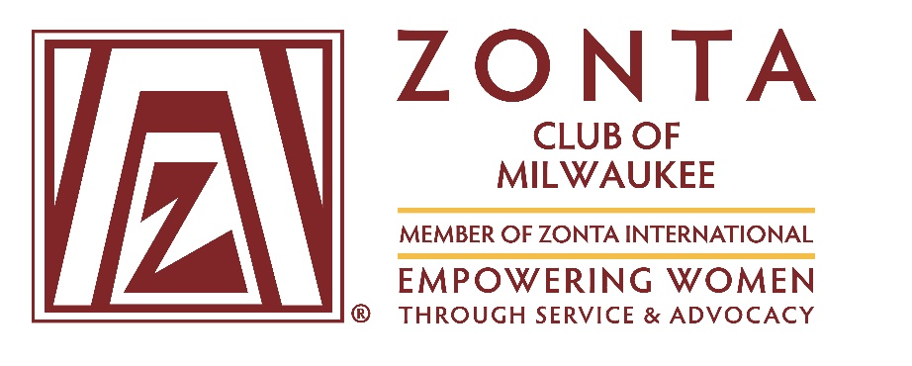
ZONTA Foundation, Inc.
2022 FUNDING GUIDELINES

General Information

Zonta International was founded in 1919 and is a leading global organization of professionals with more than 29,000 members in 63 countries. The organization seeks to empower women worldwide by improving the legal, political, economic, educational, health and professional status of women at the global and local levels through service and advocacy. With the generosity and collective action of Zontians and friends around the world, Zonta International has supported projects in 66 countries, provided scholarships and awards to women around the globe, and has been a powerful advocate for change in our local and international communities, thereby transforming the world and women's place in it.

Zonta Club of Milwaukee was chartered in 1926 as the 39th local club of Zonta International.

Zonta Foundation, Inc. was established in 1957 as the charitable arm of the Zonta Club of Milwaukee. Classified as a 501(c)(3) non-profit organization, the foundation’s primary role is to raise and distribute funds. Each year, one-third of the funds raised are used to support Zonta International service projects, while the remaining two-thirds are distributed locally to provide scholarships and support programs designed to improve the lives of women and/or girls.

2022 Grants Program

In keeping with the mission and goals of Zonta International and the Zonta Club of Milwaukee, Zonta Foundation, Inc. is soliciting Funding Applications from 501(c)(3) non-profit agencies/organizations for specific programs, projects or services that are designed to empower women and/or girls.

Eligibility: 501(c)(3) non-profit agencies/organizations serving women and/or girls in the greater Milwaukee area.

Grant Amounts: Individual grants typically range from $1,000-$3,000 per year, with commitments up to 3 years. However, the Foundation Board will consider requests for larger awards. Applicants should keep in mind that preference is generally given to funding requests for specific programs, projects or services versus unspecified contributions to a general operating fund.

Application Process: 2022 Funding Applications, with the required supporting documentation, must be sent to Zonta Foundation, Inc. in time to arrive by the due date below. Electronic submissions via email as Word documents are preferred.

Due Date: | July 15, 2022
Email Address: | zfoundation@zontamilwaukee.org
Mailing Address : | Zonta Foundation, Inc., c/o Janet Kloser 5996 Teakwood Dr. Greendale, WI 53129

Funding Decisions: The Board of Directors of Zonta Foundation, Inc. will review all applications and will make their final decisions by the end September.

Award Presentations: Grants will be presented to recipients at the Zonta Club of Milwaukee’s Fashion Show Fundraising Event that is planned for November 5, 2022.

Other Requirements: Grantees must consent to: (1) the electronic or hard copy publication of material contained in the application for Zonta’s internal use or publicity purposes, (2) the use of their agency/organization name and photographs in communications designed to promote Zonta International, Zonta Club of Milwaukee and/or Zonta Foundation, Inc., and (3) the submission of funded program/project/service reviews or status reports at mid-year, or other mutually agreed upon dates.

Additional Information: More information about Zonta can be found at www.zonta.org and www.zontamilwaukee.org. If you have any questions about 2022 foundation grants, please contact us by email at zfoundation@zontamilwaukee.org.
Zonta Foundation, Inc.
2022 FUNDING APPLICATION

Applications are due July 15, 2022 and must include the following information in the order listed below.
Applicant Profile

Agency/Organization : |  |  |  | 501(c)(3)Status (yes or no):
Mailing Address: |  |  | Website:
Exec. Director/CEO: | Name: |  | Title:
 | Phone: |  | Email:
Funding Contact: | Name: |  | Title:
 | Phone: |  | Email:

- Mission/Vision of Agency/Organization:

- Agency/Organization Operating Budget: Please include a copy of your operating budget.

- Annual Report: Please provide a copy of the latest annual report.

- Has your Agency/Organization ever received funding from Zonta Foundation, Inc. in the past? If so, could you describe how this has impacted the women and/or girls you serve over time.

Funding Request

- Describe the Program/Project/Service for which you are requesting funding. How does this Program/Project/Service empower women and/or girls? What impact will this grant have on your current operations?

- State your proposed Program/Project/Service Goals and Activities in terms of the targeted population and eligibility, number served, success criteria and performance measures. Describe quantifiable outcomes and expectations for the Program/Project/Service and how you will measure these results.

- Does your agency/organization have a history of running successful programs for women and/or girls? If Yes, briefly describe them and their outcomes.

- Indicate the Amount of Funding being requested.

- Provide the Specific Budget and Funding Sources (including in-kind services and active and pending grants) for the proposed Program/Project/Service.

- What Community Partnerships does the agency/organization have or use?

- In what other ways could the Zonta Club of Milwaukee supplement/support the program/project/service with hands-on service, advocacy, in-kind donations or other involvement?

Other Requirements

If you receive a donation from Zonta Foundation, Inc. explain how you will acknowledge it, i.e. annual report, newsletter, website, social media, etc.

Declaration by Applicant

I certify that all the information contained in this application is accurate to the best of my knowledge, and on behalf of my agency/organization, I consent to: (1) the electronic or hard copy publication of material contained in the application for Zonta’s internal use or publicity purposes, (2) the use of our agency/organization name and photographs in communications designed to promote Zonta International, Zonta Club of Milwaukee and/or Zonta Foundation, Inc., and (3) the submission of funded program/project/service reviews or status reports at mid-year, or other mutually agreed upon dates.
Signature: |  | Title: |  | Date:

Submit Application electronically as Word document to zfoundation@zontamilwaukee.org or
mail directly to Zonta Foundation, Inc., c/o Janet Kloser 5996 Teakwood Dr. Greendale, WI 53129

